North Eastern Space Applications Centre

Samar – **s**pace based **a**nalysis for **m**onitoring of **a**gro-**r**esources

Ashish Patel

**Supervisor:** Scientist ‘SD’ Pradesh Jena



Agriculture and Soil Division

Government of India, Department of Space  
Umiam, Meghalaya

22/06/2024

# **Declaration**

This report has been prepared on the basis of my own work. Where other published and unpublished source materials have been used, these have been acknowledged.

Word Count: 20054

Student Name: Ashish Patel

Date of Submission:

Signature:

Contents

**Declaration** 2

Abstract 5

Project Specification 5

Project Title: 6

Objective: 6

Scope: 6

System Architecture: 6

Key Features: 6

Technologies Used: 6

Implementation Phases: 7

Expected Outcomes: 7

Constraints: 7

Future Enhancements: 7

Chapter 1: Introduction 8

**1.1** Purpose of Report 8

**1.2** Overview Of Automated Exam System 9

**1.3** Need of Automated Exam Systems 10

**1.4** Advantages of Automated Exam Systems 12

Chapter 2: Project Overview 15

**2.1** Background Of Automated Exam System 15

2.1.1 Evaluation 16

2.1.2 Challenges 18

**2.2** Objectives Of the Project 20

2.2.1 Addressing 20

2.2.2 Enhancing 22

Chapter 3: System Design 25

**3.1** Architecture of the Automated Exam System 25

3.1.1 High-level System Components 25

3.1.2 Interaction between Components 26

**3.2** Functional Requirements 28

3.2.1 Question Generation Module 30

3.2.2 Answer Evaluation Module 31

**3.3** Non-functional Requirements 32

Chapter 4: Implementation 34

**4.1** Technology Stack 34

4.1.1 Programming Languages and Frameworks 34

4.1.2 Database Management System 34

**4.2** Development Process 34

4.2.1 Agile Methodology 35

4.2.2 Iterative Development Cycle 35

Chapter 5: User Interface Design 36

**5.1** Interface for Educators 36

5.1.1 Features and Functionalities 37

5.1.2 Ease of Use and Navigation 39

**5.2** Interface for Students 40

5.2.1 Access to Exam Materials 42

5.2.2 Submission of Answers 43

Chapter 6: Testing and Validation 45

**6.1** Testing Procedures 45

6.1.1 Unit Testing 45

6.1.2 Integration Testing 46

**6.2** Validation of Results 47

6.2.1 Comparison with Manual Evaluation 48

6.2.2 Feedback from Users 49

Chapter 7: Future Enhancements 51

**7.1** Integration of Advanced Technologies 51

7.1.1 Augmented Reality and Virtual Reality 51

7.1.2 Enhanced Natural Language Processing 52

Chapter 8: Conclusion 53

Chapter 9: Work Distribution 55

Chapter 10: References 57

Chapter 11: Bibliography 58

Chapter 12: Annexure A: Source Code 60

# Abstract

Land use and land cover change has become a central component in current strategies for managing natural resources and monitoring environmental changes.

Land classification and segmentation by manual means have for long been limited by inefficiencies that take valuable time and resources. As such the LCLU comes as a sophisticated answer to these challenges. This system employs cutting-edge technologies, including machine learning (ML), object-based image segmentation (OBIS) and advanced python modules to automate and enhance land classification processes.

This research paper endeavours to examine in detail the development, implementation, and potential impact of the LCLU system. Basically, this system uses ML algorithms to accomplish an efficient land cover classification. Deeper insights will be provided by algorithms such as Random Forest, Support Vector Machine (SVM), Deep Learning, K-Nearest Neighbours (KNN). Furthermore, the system incorporates different OBIS techniques such as clustering-based segmentation, neural networks, Otsu’s method, Prewitt operator network region-based segmentation Robert cross operator thresholding for accurate and reliable land segmentation.

The LCLU system has been successful largely because it has managed to integrate python modules and pretrained models so smoothly that it is easy for people to understand. It allows analysts and users to interact with the system easily by enabling them to upload satellite images, monitor classification progress and access detailed analytics about land usage. By being accessible in this manner, the LCLU system becomes a powerful environmental analytical tool while also providing researchers and policy makers with an efficient way of traversing through the intricacies of contemporary land management.

The growth in need for accurate land classification and monitoring due to environmental concerns and urban development underscores the importance of innovative approaches such as the LCLU system. This demand has increased at an exponential rate as global challenges like climate change and deforestation continue rising. The LCLU system is on top of this trend, set to retain its position after changing towards more advanced needs for environmental monitoring plus land administration.

Looking forward, the potential of the LCLU system and ML-driven land classification is vast. As technology advances, possibilities for creativity in ecological monitoring are endless. By featuring augmented reality (AR) and virtual reality (VR), this approach enhances analysis experiences and provides immersive as well as interactive visualization of land data. Moreover, recent improvements in machine learning and image processing provide an opportunity to fine-tune classification algorithms so that they can be more descriptive for detailed as well as contextually aware assessments on land use.

In sum, the LCLU Classification System offers a comprehensive response to challenges inherent in conventional methods – it signifies a paradigm shift in environmental monitoring and land management. This paper shows how the LCLU system could revolutionize landscape of land classification for efficiency, accuracy, and accessibility in the digital era. The LCLU system remains at the forefront among technological solutions applied to environmental management, aiming at redefining 21st-century classifications of territories. As such, it would be safe to say that this paper underscores how environmental monitoring has shifted towards technology-based solutions through which the future direction of 21st-century land mapping is being driven by innovative approaches like this LCLU system.

# Project Specification

## Project Title:

### NESACTITLE –ML based Land Cover and Land Use Classification System

### Objective:

### To develop an automated land cover and land use classification system featuring object-based image segmentation (OBIS) and machine learning algorithms to provide an efficient and accurate alternative to traditional manual methods.

### Scope:

* Develop an application that can automatically classify land cover and land use from satellite and UAV images.
* Implement machine learning algorithms and OBIS techniques to enhance classification accuracy.
* Ensure secure and reliable handling of environmental data to maintain data integrity and prevent loss.

### System Architecture:

* Frontend: User interface developed using Python's Tkinter for ease of use and accessibility.
* Backend: Powered by Python and relevant libraries to handle data processing, image segmentation, and land classification.

### Key Features:

* Automated Land Classification: Use machine learning models to classify various land cover and land use types from satellite images.
* Object-Based Image Segmentation (OBIS): Employ techniques like clustering-based segmentation, neural networks, and thresholding for precise land segmentation.
* Real-time Analysis: Provide immediate feedback and results to users upon submission of satellite images.

### Technologies Used:

* Programming Languages: Python (for both frontend and backend)
* Frontend Modules: Tkinter (for GUI development)
* Machine Learning and OBIS Libraries:
* GDAL: For reading and processing geospatial data.
* OpenCV: For image processing.
* Ultralytics YOLO: For object detection.
* NumPy: For numerical computations.
* Matplotlib: For plotting and visualization.
* Pandas: For data manipulation and analysis.
* Scikit-Learn: For machine learning algorithms like Random Forest, SVM, KNN, and clustering (KMeans, Gaussian Mixture).
* TensorFlow: For neural networks and deep learning models.
* Scipy: For advanced image processing and segmentation techniques.
* Skimage: For image processing, segmentation, and feature extraction.
* PIL: For image manipulation and display.
* TiffFile: For handling TIFF image files.

### Implementation Phases:

* Phase 1: Requirement analysis and system design
* Phase 2: Development of the desktop application interface using Tkinter
* Phase 3: Integration of machine learning and OBIS algorithms
* Phase 4: Testing and validation of the system
* Phase 5: Deployment and user training
* Phase 6: Monitoring and maintenance

### Expected Outcomes:

* Accurate classification of land cover and land use from satellite images.
* Enhanced efficiency and reliability compared to traditional manual methods.
* User-friendly interface for easy interaction and analysis.

### Constraints:

* Availability of high-quality satellite images.
* Computational resources required for processing large images.
* Ensuring data security and user privacy.

### Future Enhancements:

* Integration of augmented reality (AR) and virtual reality (VR) for immersive visualization.
* Advanced natural language processing (NLP) for more detailed analysis and reporting.
* Continuous improvement of machine learning models with more extensive datasets..

This specification outlines the framework for the NESACTITLE – ML based Land Cover and Land Use Classification System project, highlighting its goals, architecture, features, and implementation strategy

# Introduction to GIS

A Geographic Information System (GIS) is a computer system that analyzes and displays geographically referenced information. It uses data that is attached to a unique location. If, for example, a rare plant is observed in three different places, GIS analysis might show that the plants are all on north-facing slopes that are above an elevation of 1,000 feet and that get more than ten inches of rain per year. GIS maps can then display all locations in the area that have similar conditions, so researchers know where to look for more of the rare plants. By knowing the geographic location of farms using a specific fertilizer, GIS analysis of farm locations, stream locations, elevations, and rainfall will show which streams are likely to carry that fertilizer downstream. These are just a few examples of the many uses of GIS in earth sciences, biology, resource management, and many other fields.

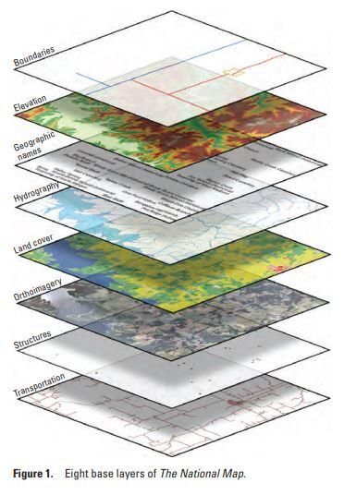

## What is GIS?

Gis a system designed to capture, store, manipulate, analyze, manage, and present spatial or geographic data. It combines layers of information about a place to give a better understanding of that place. These layers of information can be anything from physical features like mountains, rivers, and roads to more complex data like the distribution of diseases, land use, and demographics.

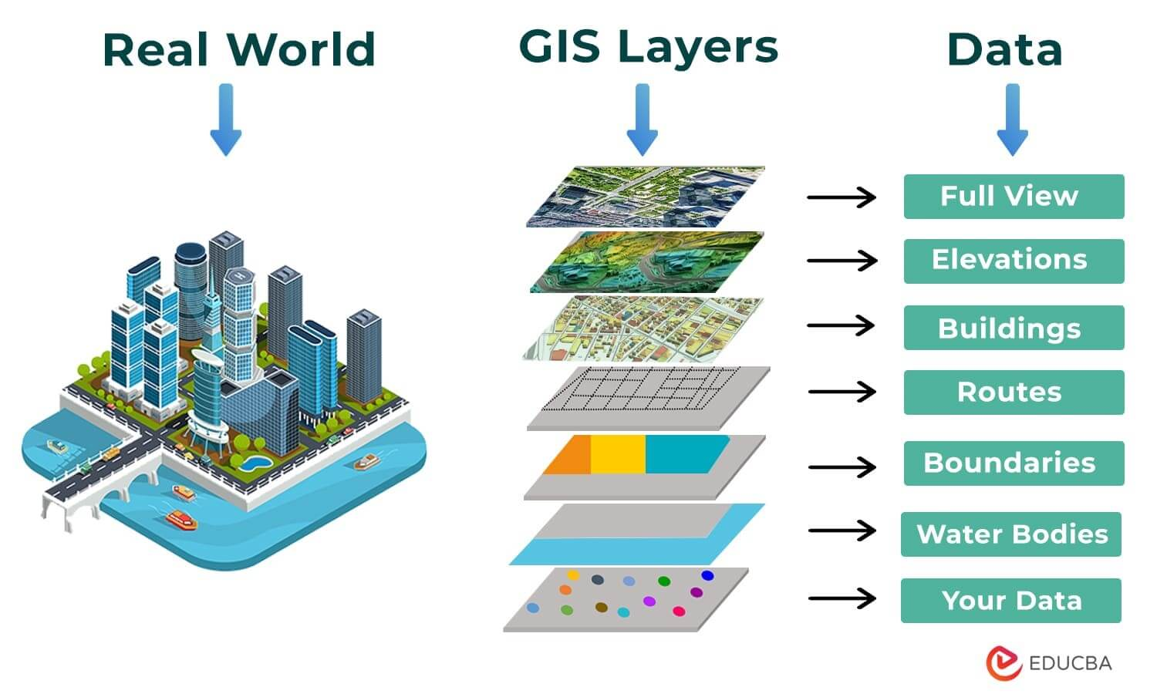

## Components of GIS

GIS is composed of five key components:

1. **Hardware**: The physical devices on which a GIS operates. This includes computers, servers, GPS devices, and other related hardware.
2. **Software**: Programs and applications used to process and analyze spatial data. Examples include ArcGIS, QGIS, and GRASS GIS.
3. **Data**: The raw information that GIS processes. This can be spatial data (maps, satellite images) or attribute data (descriptions, measurements).
4. **People**: The users who input, analyze, and interpret GIS data. They include GIS specialists, analysts, and decision-makers.
5. **Methods**: The procedures and techniques used to collect, analyze, and interpret GIS data. This involves data collection methods, data processing techniques, and analytical method

## Types of GIS Data

In Geographic Information Systems (GIS), data is categorized broadly into spatial and non-spatial data types, each serving distinct purposes and used in various applications.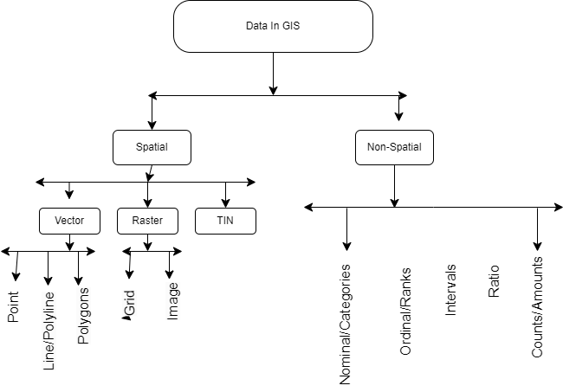

### Spatial Data

**Definition:** Spatial data refers to information that has a direct association with geographic locations or positions on the Earth's surface. It describes where things are located and their spatial relationships.

**Types of Spatial Data:**

#### Vector Data:

* Uses points, lines, and polygons to represent discrete geographic features.
* **Points:** Represent specific locations, such as cities or sampling sites.
* **Lines:** Represent linear features like roads, rivers, or pipelines.
* **Polygons:** Represent areas with defined boundaries, such as land parcels or administrative boundaries.
* Examples: Cadastral maps, road networks, land use zoning.

#### Raster Data:

* Composed of a grid of cells or pixels, each with a value representing a specific attribute or phenomenon.
* **Continuous Data:** Represents continuous fields like elevation models, temperature maps, and satellite imagery.
* Examples: Digital Elevation Models (DEMs), satellite imagery, climate data.

**Characteristics:**

* **Spatial Extent:** Defines the geographic coverage of the data.
* **Resolution:** Determines the level of detail or granularity.
* **Coordinate System:** Specifies the spatial reference framework (e.g., latitude-longitude, UTM).
* **Attributes:** Often linked to attribute tables containing descriptive information about each spatial feature.

**Applications:**

* **Spatial Analysis:** Includes proximity analysis, overlay operations, spatial interpolation, and network analysis.
* **Mapping and Visualization:** Used for creating maps, thematic maps, and spatial representations.
* **Modeling:** Supports spatial modeling for environmental modeling, urban planning, and natural resource management.

### Non-Spatial Data

**Definition:** Non-spatial data, also known as attribute or tabular data, describes characteristics or attributes associated with spatial features. Unlike spatial data, it does not have direct geographic coordinates but is linked to spatial data through identifiers or keys.

**Types of Non-Spatial Data:**

1. **Tabular Data:**
   * Organized in tables with rows and columns, where each row represents a spatial feature or object, and each column represents an attribute or characteristic.
   * Examples: Population statistics, land ownership details, temperature records.
2. **Textual Data:**
   * Descriptive information associated with spatial features, often stored in narrative form or documents.
   * Examples: Reports, survey responses, textual descriptions of features.

**Characteristics:**

* **Attributes:** Represent specific characteristics or properties of spatial features.
* **Relationships:** Often linked to spatial data through unique identifiers or keys.
* **Formats:** Can be stored in various formats, including databases, spreadsheets, and text files.

**Applications:**

* **Data Analysis:** Statistical analysis, trend analysis, and data mining.
* **Decision Support:** Provides context and additional information for making informed decisions.
* **Documentation:** Supports data documentation, metadata creation, and record-keeping.

#### Integration of Spatial and Non-Spatial Data

GIS systems integrate spatial and non-spatial data to provide comprehensive insights and support decision-making processes. By combining spatial location with descriptive attributes, GIS users can analyze spatial patterns, relationships, and trends effectively. This integration enhances the utility and value of GIS applications across diverse fields such as environmental science, urban planning, agriculture, and public health.

## Types of GIS Data Sources

GIS data can be derived from various sources, including:

1. **Aerial Data**:
   * Captured from aircraft or drones, providing high-resolution images of the Earth's surface.
   * Useful for detailed analysis of land use, urban planning, and environmental monitoring.
2. **Satellite Data**:
   * Collected from satellites orbiting the Earth, offering broad coverage for monitoring large-scale environmental changes.
   * Used in applications such as climate change studies, deforestation tracking, and agricultural monitoring.
3. **LIDAR Data**:
   * Uses laser pulses to measure distances to the Earth's surface, generating detailed 3D models.
   * Valuable for topographic mapping, forestry, and urban planning.
4. **Drone Data**:
   * Captured by UAVs equipped with cameras and sensors, providing high-resolution and flexible data collection.
   * Effective for localized surveys, precision agriculture, and disaster assessment.
5. **Ground Surveys**:
   * Data collected through direct measurements on the ground using tools like GPS and total stations.
   * Provides highly accurate and specific information, often used to validate remote sensing data.

## Applications of GIS

GIS has a wide range of applications across various fields:

1. **Urban Planning**:
   * Helps in designing and managing urban infrastructure, zoning, and land use planning.
   * Facilitates efficient allocation of resources and services.
2. **Environmental Management**:
   * Monitors and manages natural resources, wildlife habitats, and environmental changes.
   * Supports conservation efforts and environmental impact assessments.
3. **Disaster Management**:
   * Assists in disaster preparedness, response, and recovery by mapping hazard zones and assessing risk.
   * Enhances coordination during emergency situations through real-time data.
4. **Agriculture**:
   * Supports precision farming by analyzing soil conditions, crop health, and irrigation needs.
   * Optimizes resource use and increases agricultural productivity.
5. **Transportation**:
   * Aids in route planning, traffic management, and infrastructure development.
   * Improves efficiency and safety of transportation networks.
6. **Public Health**:
   * Tracks the spread of diseases, maps health facilities, and analyzes health data spatially.
   * Enhances the delivery of healthcare services and epidemic response.

## GIS Technologies

Several technologies underpin GIS, enabling its capabilities:

1. **Global Positioning System (GPS)**:
   * Provides accurate location data through satellites.
   * Essential for mapping and spatial data collection.
2. **Remote Sensing**:
   * Captures data about the Earth's surface from satellites and aircraft.
   * Invaluable for monitoring and analyzing environmental and geographic changes.
3. **Geospatial Databases**:
   * Stores and manages large volumes of spatial data.
   * Examples include PostGIS, Oracle Spatial, and SQL Server Spatial.
4. **Web Mapping Services**:
   * Deliver GIS data and maps over the internet.
   * Examples include Google Maps, OpenStreetMap, and ArcGIS Online.
5. **Spatial Analysis Tools**:
   * Perform complex analyses on spatial data to identify patterns and relationships.
   * Include tools for buffering, overlay, spatial statistics, and more.

## Future Trends in GIS

The field of GIS is continuously evolving with advancements in technology and methodology. Future trends include:

1. **Artificial Intelligence (AI) and Machine Learning**:
   * Enhancing GIS capabilities through predictive analytics and automated feature extraction.
   * Improving accuracy and efficiency in data analysis and decision-making.
2. **Big Data Integration**:
   * Managing and analyzing large datasets from diverse sources.
   * Enabling more comprehensive and real-time spatial analysis.
3. **3D GIS**:
   * Expanding from 2D maps to 3D models for more realistic and detailed representations.
   * Useful for urban planning, infrastructure development, and environmental modeling.
4. **Internet of Things (IoT)**:
   * Integrating IoT devices with GIS for real-time monitoring and data collection.
   * Applications include smart cities, environmental monitoring, and transportation systems.
5. **Cloud-based GIS**:
   * Leveraging cloud computing for scalable, accessible, and cost-effective GIS solutions.
   * Facilitates collaboration and data sharing across organizations and geographies.

By understanding the comprehensive capabilities and applications of GIS, stakeholders can leverage this powerful tool to make informed decisions, optimize resources, and address complex spatial challenges effectively.

# Introduction To Land Use and Land Classification(LCLU)

In recent years, the importance of accurate and efficient land cover and land use (LCLU) classification has grown significantly, driven by the need for sustainable environmental management, urban planning, and resource allocation. Traditional methods of land classification often involve manual interpretation of satellite images and field surveys, which are time-consuming, resource-intensive, and prone to human error. These conventional approaches fail to keep pace with the rapid changes in land use patterns, necessitating the development of more advanced, automated systems.

To address these challenges, this project focuses on developing NESACTITLE, an advanced system for land cover and land use classification utilizing object-based image segmentation (OBIS) and machine learning algorithms. The primary objective is to create a robust, efficient, and accurate classification system that can process and analyse satellite imagery with minimal human intervention, thereby enhancing the reliability and timeliness of LCLU data.

The NESACTITLE system integrates a range of cutting-edge technologies. Python serves as the foundational programming language, leveraging its extensive libraries for data processing, machine learning, and image analysis. The graphical user interface (GUI) is developed using Tkinter, providing a user-friendly platform for users to interact with the system. Various machine learning algorithms, including Random Forest, Support Vector Machine (SVM), K-Nearest Neighbours (KNN), and deep learning techniques, are employed to classify land use categories. Additionally, OBIS techniques such as clustering-based segmentation, region-based segmentation, and neural networks are used to improve the accuracy and granularity of the classification process.

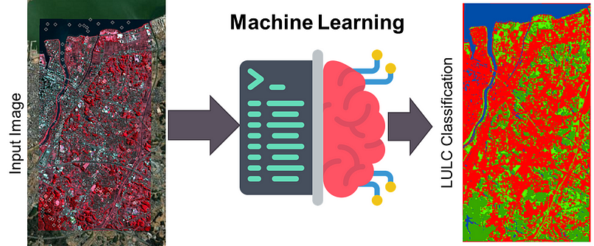

A significant component of the NESACTITLE system is its application in real-world scenarios, such as the classification of land cover in regions like Shillong and Meghalaya. These areas present diverse and complex landscapes, offering an ideal testbed for evaluating the effectiveness of the system. By accurately classifying various land cover types in these regions, the system demonstrates its capability to support environmental monitoring, urban planning, and resource management efforts.

The integration of Geographic Information Systems (GIS) further enhances the system's functionality, allowing for the visualization and analysis of spatial data. GIS plays a crucial role in managing, analyzing, and presenting geographical data, thereby supporting decision-making processes in various sectors including agriculture, forestry, urban development, and environmental conservation.

### Purpose of Report

The purpose of this report is to provide comprehensive and detailed documentation of the development, implementation, and potential impact of the NESACTITLE system. This advanced land cover and land use (LCLU) classification system leverages cutting-edge machine learning algorithms, object-based image segmentation (OBIS) techniques, and Geographic Information Systems (GIS) to enhance the accuracy and efficiency of land classification processes. The report aims to elucidate the various components, methodologies, and technologies employed in the creation of the system, offering a thorough understanding of its architecture and functionality.

One of the primary objectives of this report is to do the underlying motivations for the development of an advanced LCLU classification system. It seeks to highlight the inefficiencies, challenges, and limitations inherent in traditional land classification methods, thereby establishing a compelling case for the necessity and benefits of automation and advanced technologies in this context. By identifying these pain points, the report aims to provide a clear rationale for transitioning to a more modern, technology-driven approach to land use analysis.

Additionally, this report serves to outline the specific goals and objectives of the NESACTITLE system. It details how the system aims to enhance the efficiency and accuracy of land classification by automating the analysis of satellite imagery and incorporating advanced OBIS and machine learning techniques. The report also discusses how the system addresses the need for timely and reliable LCLU data, which is crucial for effective environmental management, urban planning, and resource allocation.

Furthermore, this report provides an in-depth overview of the technological infrastructure underpinning the NESACTITLE system. It discusses the selection and integration of various technologies, including Python for programming, Tkinter for GUI development, and machine learning algorithms such as Random Forest, Support Vector Machine (SVM), K-Nearest Neighbors (KNN), and deep learning techniques for LCLU classification. The report also delves into the application of OBIS techniques like clustering-based segmentation and region-based segmentation, as well as the use of GIS for spatial data analysis and visualization. By detailing the technical aspects of the system, the report aims to offer valuable insights into the design and implementation process, serving as a reference for future developments in this domain.

Ultimately, the report aspires to convey the transformative potential of the NESACTITLE system in the field of land classification and environmental management. It aims to demonstrate how such a system can significantly reduce the manual effort and time required for LCLU classification, ensure consistent and accurate results, and enhance the overall efficiency and reliability of land use analysis. Through this comprehensive documentation, the report seeks to contribute to the ongoing discourse on the adoption of advanced technologies in environmental monitoring and the management of natural resources.

### Overview Of Automated Land Cover and Land Use

The NESACTITLE system is an innovative solution designed to revolutionize the traditional processes of land cover and land use (LCLU) classification by integrating advanced machine learning algorithms, object-based image segmentation (OBIS) techniques, and cutting-edge Geographic Information Systems (GIS). This system aims to address the inefficiencies and challenges associated with conventional LCLU methods, providing a more efficient, accurate, and scalable alternative.

**Core Components and Functionalities**

**1. Image Preprocessing Module:** At the heart of the automated examination system is the question generation module, which utilizes sophisticated machine learning algorithms to create a diverse array of examination questions. This module is capable of generating both subjective and objective questions across various subjects and difficulty levels. By analyzing large datasets of educational content, the system can produce contextually relevant and pedagogically sound questions, ensuring comprehensive coverage of the curriculum.

**2. Segmentation Module**: At the heart of the system is the segmentation module, which employs OBIS techniques to partition images into meaningful objects. This module uses clustering algorithms such as K-Means and advanced segmentation techniques like watershed segmentation. By identifying and isolating distinct land cover features, the system facilitates more precise classification.

**3. Classification Modules:**The classification module leverages various machine learning algorithms, including Random Forest, Support Vector Machines (SVM), K-Nearest Neighbors (KNN), and deep learning models implemented in TensorFlow. These algorithms analyze the extracted features and classify land cover types with high accuracy. The system can handle both supervised and unsupervised classification, allowing it to adapt to different datasets and requirements.

**4. User Interface Module:** The system is accessible through a user-friendly interface developed using Tkinter, a Python GUI toolkit. This interface provides intuitive tools for uploading imagery, configuring analysis parameters, and visualizing results. It includes features such as user authentication, secure access controls, and real-time monitoring of classification processes, ensuring a smooth and secure user experience.

**5. Scalability and Flexibility:** One of the significant advantages of this system is its scalability. The NESACTITLE system is designed to handle large volumes of imagery and extensive datasets, making it suitable for organizations of varying sizes, from small research teams to large environmental agencies. The flexible architecture allows for easy updates and integration of new features, ensuring that the system can adapt to evolving technological advancements and user needs.

### Technological Infrastructure

The NESACTITLE system is built on a robust technological foundation that ensures reliability, efficiency, and scalability. The primary technologies employed include:

* **Python**: Chosen for its versatility and extensive libraries, Python serves as the core programming language for developing the system’s functionalities.
* **Tkinter**: A standard Python interface to the Tk GUI toolkit, Tkinter is used to develop the graphical user interface, providing a seamless and interactive user experience.
* **Machine Learning Algorithms**: These algorithms are integral to the feature extraction and classification modules, enabling the system to learn from vast amounts of data and improve its performance over time.
* **Object-Based Image Segmentation (OBIS):** Advanced segmentation techniques are utilized to partition imagery into meaningful objects, enhancing the accuracy of the classification.
* **Geographic Information Systems (GIS):** GIS technologies are employed for spatial data analysis and visualization, providing valuable insights into land cover and land use patterns.

Byintegrating these advanced technologies, the NESACTITLE system aims to revolutionize the LCLU classification landscape, providing a more efficient, accurate, and reliable means of analyzing and managing land use. This system not only reduces the manual effort and time required for LCLU analysis but also ensures consistent and unbiased results, ultimately contributing to a more effective and equitable approach to environmental monitoring and management.

### Need of Automated Land Cover and Land Use

The necessity for automated Land Cover and Land Use (LCLU) classification systems arises from a convergence of complex challenges and inefficiencies inherent in traditional LCLU methodologies. These conventional approaches, which predominantly rely on manual processes for both data analysis and classification, present numerous issues that can be significantly mitigated through the implementation of automated systems.

**Resource Intensiveness**

One of the most prominent challenges of traditional LCLU methods is their considerable resource intensiveness. The manual analysis and classification of land cover data are laborious tasks that demand extensive cognitive effort and substantial time investment from researchers and analysts. This process often requires meticulous examination of satellite imagery, extensive field verification, and repeated iterations to ensure that the classifications are both accurate and aligned with real-world conditions. Additionally, the manual processing of large datasets further exacerbates the workload, as analysts must individually assess each segment, which can be particularly onerous in regions with vast and diverse landscapes. This extensive consumption of human resources not only strains the analysts but also diverts their attention from other critical environmental monitoring and management responsibilities.

**Accuracy and Consistency Challenges**

Traditional LCLU classification systems are fraught with accuracy and consistency challenges. Human analysts, despite their expertise and best intentions, are inherently prone to biases and errors in classification. The subjectivity involved in the manual interpretation of satellite imagery can lead to significant variability in results, depending on the individual analyst’s judgment and experience. This issue is particularly pronounced in areas with subtle or complex land cover features, where personal biases and varying standards can influence the classification process. Such inconsistencies not only affect the reliability and accuracy of the classifications but also can result in a lack of trust in the LCLU data among stakeholders and decision-makers.

**Scalability Issues**

As environmental monitoring needs expand, the logistical complexities associated with the manual administration of LCLU classification become increasingly untenable. The traditional approach to LCLU management, which is already resource-intensive, becomes exponentially more challenging and inefficient with scale. This is particularly problematic for large-scale environmental studies and projects that must classify land cover for extensive areas across multiple regions. The manual system’s inability to efficiently scale to meet the demands of growing datasets poses significant administrative and operational burdens, leading to delays and potential errors in the classification process.

**The Imperative for Automation**

In light of these multifaceted challenges, the imperative for transitioning to an automated LCLU classification system becomes abundantly clear. Automated systems can dramatically reduce the resource burden on analysts by streamlining the data analysis and classification processes through advanced algorithms and machine learning techniques. These systems can analyze large datasets quickly and accurately, ensuring comprehensive and consistent classifications without the extensive time and effort required in manual processes.

In conclusion, the adoption of automated LCLU classification systems is not merely a technological advancement but a necessary evolution in environmental monitoring and management. By addressing the inherent inefficiencies, accuracy challenges, consistency issues, and scalability problems of traditional methods, automated systems provide a more efficient, accurate, and reliable framework for LCLU analysis, ultimately enhancing the quality and effectiveness of environmental monitoring efforts.

### Advantages of Land Cover and Land Use Systems

The advantages of automated Land Cover and Land Use (LCLU) classification systems are extensive, significantly enhancing the efficiency, accuracy, and scalability of environmental monitoring and management processes. These benefits are derived from the integration of advanced machine learning algorithms, remote sensing techniques, and modern data processing frameworks, which collectively empower automated systems to streamline operations, ensure precise classifications, and support large-scale environmental analysis.

**Enhanced Efficiency and Productivity**

One of the foremost advantages of automated LCLU systems is their ability to dramatically enhance efficiency and productivity throughout the classification lifecycle. By automating the labor-intensive processes of data analysis and classification, these systems significantly reduce the time and effort required from analysts, enabling them to allocate their resources more effectively towards other critical environmental monitoring and management tasks. Automated systems can rapidly process large volumes of satellite imagery and other geospatial data, ensuring timely updates and comprehensive coverage of land use patterns, which is essential for effective environmental planning and decision-making.

Moreover, the automation of data processing eliminates the need for manual interpretation, which can be particularly time-consuming in the case of large and complex datasets. Advanced machine learning algorithms can analyze and classify land cover features with high accuracy, providing timely and actionable insights to support environmental conservation and management efforts. This efficiency gain not only enhances the overall productivity of analysts but also enriches the quality of environmental data by ensuring consistency and reducing the potential for human error.

**Improved Accuracy and Consistency**

Automated LCLU systems offer a significant improvement in the accuracy and consistency of land cover classifications. Traditional manual classification methods are prone to human error and subjective biases, leading to variability in results. Automated systems, on the other hand, apply standardized algorithms and criteria uniformly across all data, ensuring consistent and unbiased classifications. Machine learning algorithms, trained on extensive datasets, can recognize and classify complex land cover features with high precision, reducing the likelihood of misclassification and enhancing the reliability of the results.

Additionally, automated systems can continuously learn and adapt from new data, improving their accuracy over time. This continuous improvement capability ensures that the system remains up-to-date with evolving land use patterns and environmental conditions, providing more accurate and reliable classifications for long-term monitoring and analysis.

**Scalability and Flexibility**

One of the inherent strengths of automated LCLU systems is their scalability and flexibility to accommodate the evolving needs of environmental monitoring and management. Traditional manual methods struggle to scale effectively to meet the demands of large and complex datasets, leading to logistical challenges and inefficiencies. Automated systems, however, are designed to handle large volumes of data efficiently, making them suitable for extensive environmental studies and projects that require comprehensive land cover analysis across vast geographic areas.

Moreover, automated systems are highly adaptable to different environmental contexts and requirements. They can be customized and configured to suit specific project needs, allowing for the integration of various data sources and the application of specialized classification algorithms. This flexibility ensures that automated systems can be tailored to address the unique challenges and objectives of different environmental monitoring projects, providing a versatile and scalable solution for diverse applications.

**Technological Advancements and Innovation**

Finally, automated LCLU systems drive technological advancements and innovation in the field of environmental monitoring. By leveraging cutting-edge technologies such as machine learning, remote sensing, and geospatial data analysis, these systems push the boundaries of traditional classification methodologies and enable new and innovative approaches to land cover analysis. The continuous development and integration of advanced algorithms and techniques ensure that automated systems remain at the forefront of technological innovation, enhancing their capabilities and functionalities over time.

Moreover, the adoption of automated LCLU systems fosters interdisciplinary collaboration and knowledge exchange among environmental scientists, technologists, and researchers. This collaborative ecosystem promotes a culture of innovation and experimentation, driving forward-thinking initiatives and research endeavors aimed at further improving the accuracy, efficiency, and applicability of land cover classifications. By serving as a platform for technological innovation, automated LCLU systems contribute to the continuous advancement of environmental monitoring practices, ultimately supporting more effective and sustainable environmental management.

In summary, automated LCLU systems offer a multitude of advantages that transcend the limitations of traditional classification methods. From enhancing efficiency and productivity to improving accuracy and consistency, ensuring robust security and data integrity, and fostering technological innovation, automated systems represent a transformative force in the field of environmental monitoring and management. These systems empower analysts and institutions to conduct comprehensive, accurate, and reliable land cover classifications, ultimately enhancing the quality and effectiveness of environmental monitoring efforts and supporting informed decision-making for sustainable environmental management.

### s

# Project Overview

## Backgroundof Automated Land Use and Land Classification System

The automated land use and land classification system harnesses advanced technologies to revolutionize how land use data is analyzed, classified, and managed. Traditional methods of land classification, which often rely on manual interpretation and analysis, are increasingly being replaced by automated systems that utilize machine learning, Geographic Information Systems (GIS), and remote sensing technologies. These modern approaches offer greater accuracy, efficiency, and scalability in land use planning and management.

* + 1. EvaluationOf the ExamProcesses

Traditional land classification methods involve manual interpretation of aerial photographs, satellite images, and other geographic data. This process is not only time-consuming but also prone to human error and subjectivity. Automated systems, on the other hand, use machine learning algorithms to analyze large datasets quickly and accurately. These systems can process high-resolution satellite images and other spatial data to identify land use patterns and classify land cover types with a high degree of precision.

* + 1. Challengeswith traditional LCLU Systems

Despite their advantages, automated land classification systems face several challenges:

* **Data Quality and Availability**: High-quality and up-to-date geographic data are essential for accurate land classification. In many regions, obtaining such data can be difficult and expensive.
* **Algorithm Limitations**: While machine learning algorithms are powerful, they can still struggle with complex or ambiguous land use patterns. Continuous improvement and validation of these algorithms are necessary to enhance their performance.
* **Integration with Existing Systems**: Integrating automated land classification systems with existing land management and planning systems can be complex and require significant technical expertise.

## ObjectivesOf the Project

The primary objective of this project is to develop an automated land use and land classification system that addresses the limitations of traditional methods and leverages modern technologies to enhance the efficiency and accuracy of land use analysis.

* + 1. AddressingExisting Challenges

**Data Quality and Integration:** Improve the quality and accessibility of geographic data and ensure seamless integration with existing land management systems.

**Algorithm Improvement:** Continuously refine machine learning algorithms to handle complex and diverse land use patterns more effectively.

**User-Friendly Interface**: Develop an intuitive user interface that allows planners and decision-makers to easily interact with the system and obtain valuable insights.

.

* + 1. EnhancingEfficiency and Accuracy

**Efficiency**: Automate the analysis and classification processes to reduce the time and effort required for land use planning.

**Accuracy**: Use advanced algorithms and high-resolution data to improve the accuracy of land classification results.

**Scalability**: Ensure that the system can handle large datasets and be applied to various geographic regions and contexts.

## Introducing GIS in Land Use and Land Classification

Geographic Information System (GIS) technology is fundamental to modern land use and land classification efforts. GIS integrates, manages, and analyzes spatial data, providing critical insights into land use patterns and trends. This section introduces GIS and its significance in the context of the project.

### What is GIS?

Geographic Information System (GIS) is a framework for gathering, managing, and analyzing data rooted in the spatial and geographic dimensions. It combines cartography, statistical analysis, and database technology to visualize and interpret data in ways that reveal relationships, patterns, and trends.

### Types of GIS Data

#### Data Collection Methods

**Aerial Data**

* Description: Obtained from aerial photography, providing high-resolution images of the Earth's surface.
* Applications: Detailed analysis of land use and land cover, identifying buildings, roads, and natural landmarks.

**Satellite Data**

* Description: Collected from satellites orbiting the Earth, offering broad coverage.
* Applications: Monitoring large-scale environmental changes like deforestation, urban expansion, and agricultural practices.

**Drone Data**

* Description: Captured by UAVs (Unmanned Aerial Vehicles) equipped with cameras and sensors, providing high-resolution images and videos.
* Applications: Flexible and accessible for various land use applications, including detailed inspections and mapping.

**LIDAR Data**

* Description: Utilizes Light Detection and Ranging technology to measure distances to the Earth's surface with laser pulses, creating detailed 3D models.
* Applications: Topographic mapping, forestry, urban planning, and creating detailed terrain models.

#### Data Representation Types

**Raster Data**

* Description: Composed of pixelated data (grid cells) representing continuous fields such as elevation, temperature, or satellite imagery.
* Applications: Each cell has a value representing information like vegetation index or land cover type, useful for continuous spatial phenomena.

**Vector Data**

* Description: Represents discrete features using points, lines, and polygons.
* Applications: Locations of cities (points), roads (lines), and boundaries of land parcels (polygons), useful for mapping specific, distinct features.

##### Types of GIS Based on Energy Sources

1. **Solar-Powered GIS:** Some GIS systems use solar panels to generate the energy needed for their operation. This type of GIS is especially useful in remote areas where conventional power sources are unavailable.
2. **Battery-Powered GIS:** Portable GIS devices often rely on rechargeable batteries, providing flexibility and mobility for fieldwork and on-site data collection.
3. **Grid-Powered GIS:** These GIS systems are connected to the main power grid, suitable for permanent installations in urban or developed areas.

### Applications of GIS in Land Use and Land Classification

* **Land Use Mapping:** GIS can generate detailed land use maps that categorize different land cover types such as urban areas, forests, agricultural lands, and water bodies.
* **Change Detection:** By comparing GIS data over time, it is possible to monitor changes in land use, such as urban expansion, deforestation, or agricultural conversion.
* **Resource Management:** GIS helps manage natural resources by analyzing spatial data related to soil quality, water resources, and vegetation cover.
* **Environmental Impact Assessment:** GIS is used to assess the environmental impact of proposed land use changes by modeling scenarios and visualizing potential outcomes.

### Benefits of GIS in Land Use Studies

* **Precision and Accuracy:** GIS provides high-precision tools for mapping and analyzing land use, leading to more accurate classifications.
* **Visualization:** GIS offers powerful visualization tools that help stakeholders understand spatial relationships and patterns through maps and 3D models.
* **Decision Support:** GIS supports decision-making by integrating and analyzing multiple data layers, helping planners and policymakers develop informed strategies for land use.

### Conclusion

The integration of GIS into automated land use and land classification systems significantly enhances the analytical capabilities and accuracy of spatial data analysis. By leveraging GIS technologies, the project aims to provide a robust, efficient, and scalable solution for land use planning and management, ultimately contributing to more sustainable and informed decision-making processes.

This chapter provides a comprehensive overview of the background, objectives, and importance of integrating GIS into the automated land use and land classification system, setting the stage for the detailed discussions in the subsequent chapters.

### fsda

### s

# s

### fsda

### s

# s

### fsda

### s

# s

### fsda

### s

# s

### fsda

### s

# s

### fsda

### s

# s